Canada as a Tourist Country

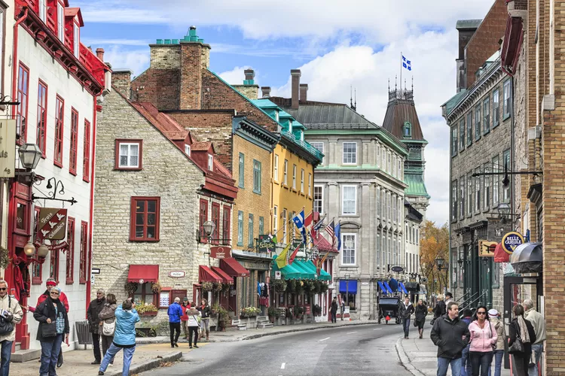

Course:

**IT Programmer Analyst**

Professor Name:

**Zoe Moeini**

Student Name:

**Pushpak Abnave**

Contents

History of Canada 3

Canada as a country 3

Tourists Attractions 4

Bibliography 10

# History of Canada

Lorem ipsum dolor sit amet, consectetur adipiscing elit. Quisque sollicitudin quam at augue ultrices, bibendum pellentesque mauris semper. Phasellus ut commodo erat, nec accumsan neque. Morbi diam est, venenatis et mauris id, ultricies feugiat libero. Vivamus sit amet mollis mi. Cras tempor velit et fringilla tincidunt. Cras a aliquet augue. Cras in aliquet turpis. Ut et varius neque. Nunc quis nunc laoreet, aliquet justo vitae, tincidunt lectus. In hac habitasse platea dictumst. Nam nulla nisl, convallis at suscipit ut, elementum ut purus. Donec augue nulla, bibendum vitae tincidunt sed, convallis et odio. Integer vitae neque tellus. Donec a laoreet nisl.

## Canada as a Country

Suspendisse tincidunt, dolor eu ultrices rutrum, augue nulla tempor turpis, nec pellentesque massa est a libero. Praesent maximus vestibulum dui vel aliquam. In hac habitasse platea dictumst. Sed et pretium orci. Morbi vitae ullamcorper lacus. Praesent gravida dui id dolor pretium ultricies. Aenean mattis tellus diam, et maximus urna efficitur quis. Ut vel tempor leo. Cras vulputate nulla vel ornare iaculis. Donec sollicitudin augue ipsum, in luctus elit varius vel. Quisque sodales vehicula nunc, eget egestas justo malesuada ac. Vivamus eu nibh ex. Nulla tristique lacus id rutrum cursus. Integer finibus maximus odio id fringilla. Quisque auctor magna ut quam consequat vestibulum. Sed tincidunt sagittis nequesuscipit.

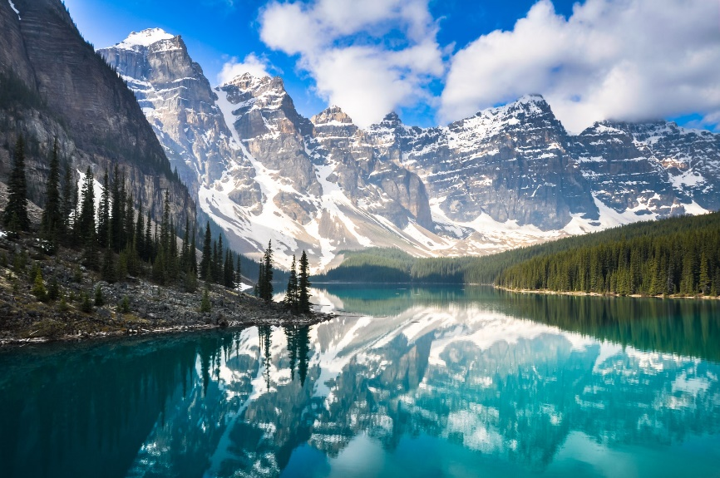

Lake Moraine, Canada

### Tourists Attractions

Vestibulum et lobortis odio. Duis euismod sed sem ut faucibus. Integer consequat nibh non eros interdum, et ultricies dolor sodales. Morbi aliquam lacinia neque vel aliquam. Nulla facilisis ex quis sem tempus facilisis. Pellentesque vitae quam sed ex euismod convallis vel vel purus. Etiam molestie fringilla ornare. Suspendisse maximus fermentum arcu, eu viverra nunc venenatis eu. Vestibulum pretium leo tortor, et tempor arcu accumsan eget. Donec vitae est sed sem dapibus convallis eu sed quam.[1]

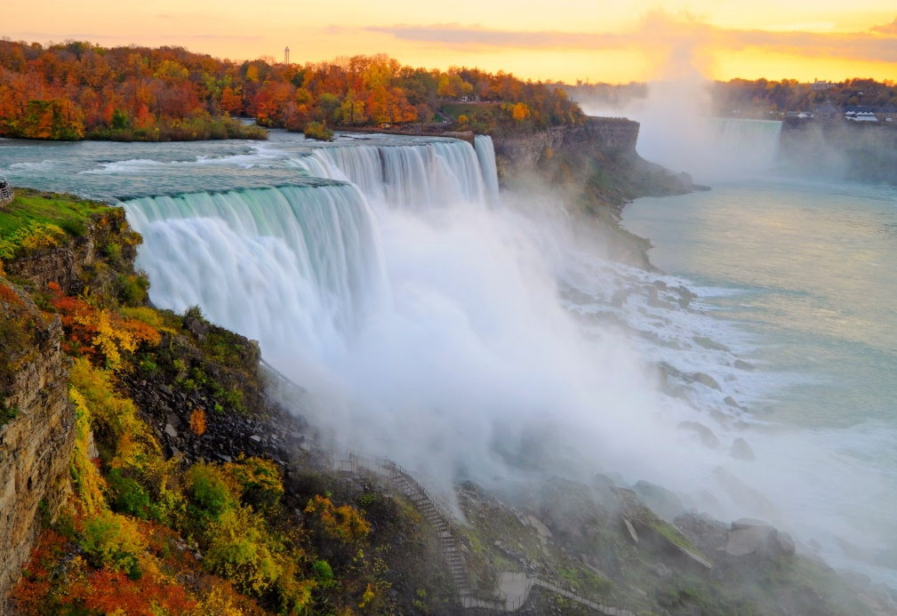

Niagara Falls

Nullam faucibus purus ac augue egestas, eu sodales nulla dignissim. Curabitur nec sapien id quam fermentum porta. Duis a odio nisl. Mauris et faucibus diam. Donec nunc arcu, interdum et felis a, auctor sodales mi. Vestibulum auctor congue ligula. Cras accumsan ante quis dolor efficitur, ut aliquam risus condimentum. Cras vel eleifend dolor, sit amet convallis ipsum. Quisque id massa nunc. Phasellus at metus blandit, varius ligula id, pharetra tellus. Aliquam condimentum ultrices mi, a pharetra lectus commodo in. Mauris eu mi sed lacus mollis bibendum. Orci varius natoque penatibus et magnis dis parturient montes, nascetur ridiculus mus. Sed ligula orci, aliquet feugiat vulputate eget, fermentum a eros. In dapibus mauris nibh, sagittis posuere dui efficitur tempor. Donec luctus ut erat ut lacinia.

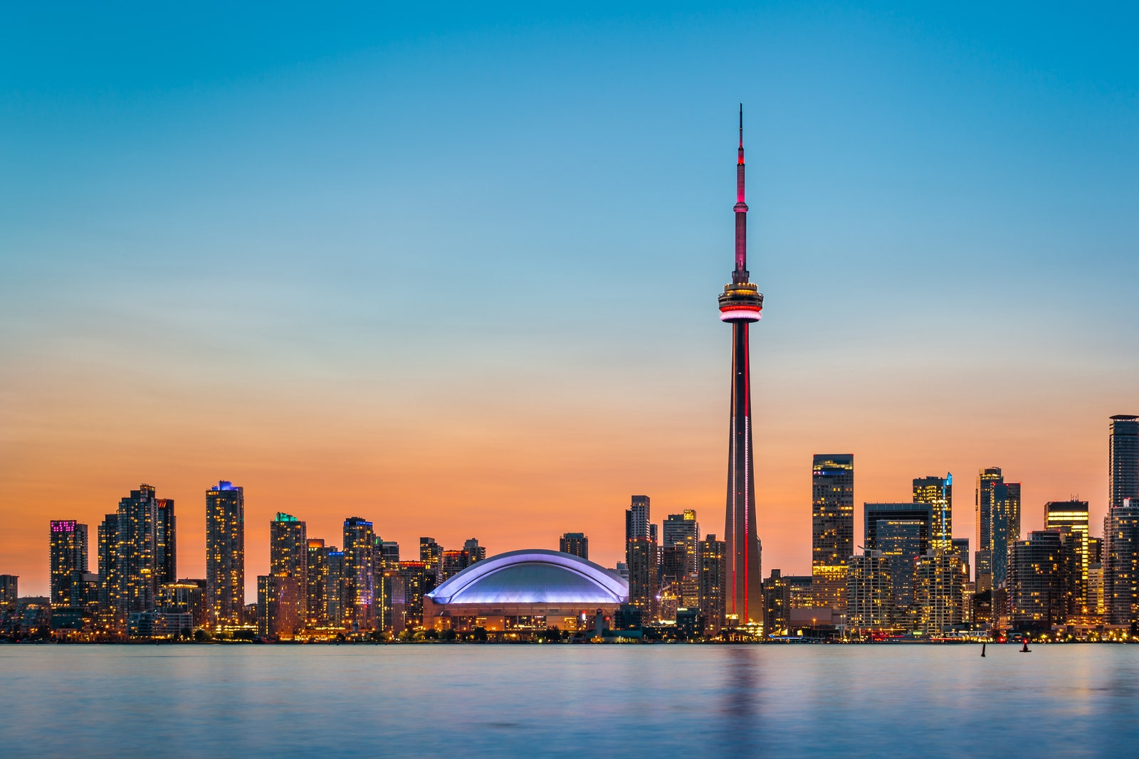

CN Tower, Toronto

Cras sed est eget metus dapibus tincidunt. Aliquam sit amet efficitur nulla. Morbi nec quam sem. Proin rutrum est ligula, et pharetra ipsum pellentesque elementum. Aenean commodo erat turpis, vitae fermentum tortor tincidunt vitae. Quisque non mollis massa, id porta sem. Integer hendrerit fringilla enim id dictum. Curabitur suscipit justo sit amet urna condimentum, bibendum elementum neque scelerisque

#### Cuisine of Montreal

Foodies and Francophiles should make a beeline for Montreal, the cultural metropolis of Québec. The French influence on the local architecture, language, and cuisine is strong, but expect more Canadian-friendly charm than Parisian directness. Plan ahead to secure reservations at Vin Mon Lapin for the most creative, high-end (but surprisingly low-key) dining in the province with an incredible natural wine selection. You can also book a table or bar seat at L’Express for a classic brasserie experience. (Pro tip: don’t end your meal without ordering the incredible île flottante for dessert.) Vin Papillon is another favorite for an elevated yet casual meal with plenty of impressive wines by the glass, while Le Passé Composé takes brunch to the next level. Of course, your culinary adventure in Montreal is not complete without a visit to St.-Viateur for their iconic bagels or La Banquise for a late-night snack of poutine.[2]

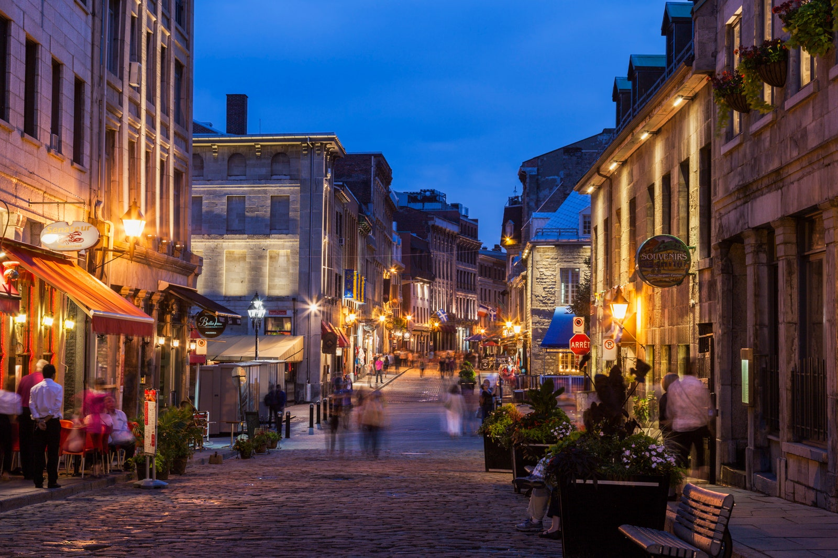

Cuisine Of Montreal

##### Internation Tourists visiting Canada

Aenean euismod sem aliquet, sollicitudin felis sit amet, pharetra nibh. Vestibulum id libero vitae lacus cursus interdum. Aenean ac dui neque. Fusce molestie felis eu faucibus iaculis. Nulla vulputate nisi magna, viverra posuere dolor dictum in. Vestibulum rutrum neque quis sem posuere eleifend. Praesent quis porta lacus. Fusce mollis purus blandit vehicula placerat. Etiam quis iaculis nisi, id dapibus metus. Nulla nec dui et odio gravida tristique. Nullam porta fringilla neque eget pulvinar. Duis odio dolor, tincidunt eget condimentum a, tristique at tortor. Ut bibendum dolor quis lectus gravida aliquet. Donec quis elit at lacus condimentum varius ac sit amet ligula. Nulla non sollicitudin arcu. [3]

|  |  |  |  |  |  |  |
| --- | --- | --- | --- | --- | --- | --- |
| Country | 2010 | 2013 | 2016 | 2019 | 2022 | 2024 |
| United States | 4,30,000 | 9,70,000 | 11,60,000 | 20,00,000 | 21,10,000 | 23,50,000 |
| Nigeria | 20,000 | 90,000 | 100,000 | 13,00,00 | 17,00,00 | 18,00,00 |
| India | 5,70,000 | 10,50,000 | 14,70,000 | 18,20,000 | 22,90,000 | 24,00,000 |
| England | 40,000 | 80,000 | 11,80,00 | 15,90,00 | 16,60,00 | 17,00,00 |
| Bangladesh | 10,000 | 20,000 | 60,000 | 75,000 | 90,000 | 11,00,00 |

###### Quality of Life

In est ex, cursus sed sodales in, ultricies et nulla. Duis vulputate elit magna, ut sodales orci gravida id. Morbi dui mi, tincidunt ut quam non, cursus interdum mi. Nullam non dolor ac turpis volutpat varius quis eget lacus. Nullam lacinia rhoncus tellus in auctor. Maecenas elementum ullamcorper nulla, a varius arcu feugiat a. Donec porta iaculis libero eget facilisis. Class aptent taciti sociosqu au litora torquent per conubia nostra, per inceptos himenaeos. Donec turpis felis, lobortis non eros in, accumsan vulputate urna. Aenean imperdiet efficitur tortor vel faucibus. Etiam at finibus eros, vehicula porttitor elit. Morbi eu feugiat quam. Suspendisse mi libero, imperdiet nec posuere eu, tempus faucibus justo. Phasellus eu felis tincidunt, tempor nibh nec, malesuada mauris. Sed metus odio, pretium eget purus ut, pharetra tempus dui.[4]

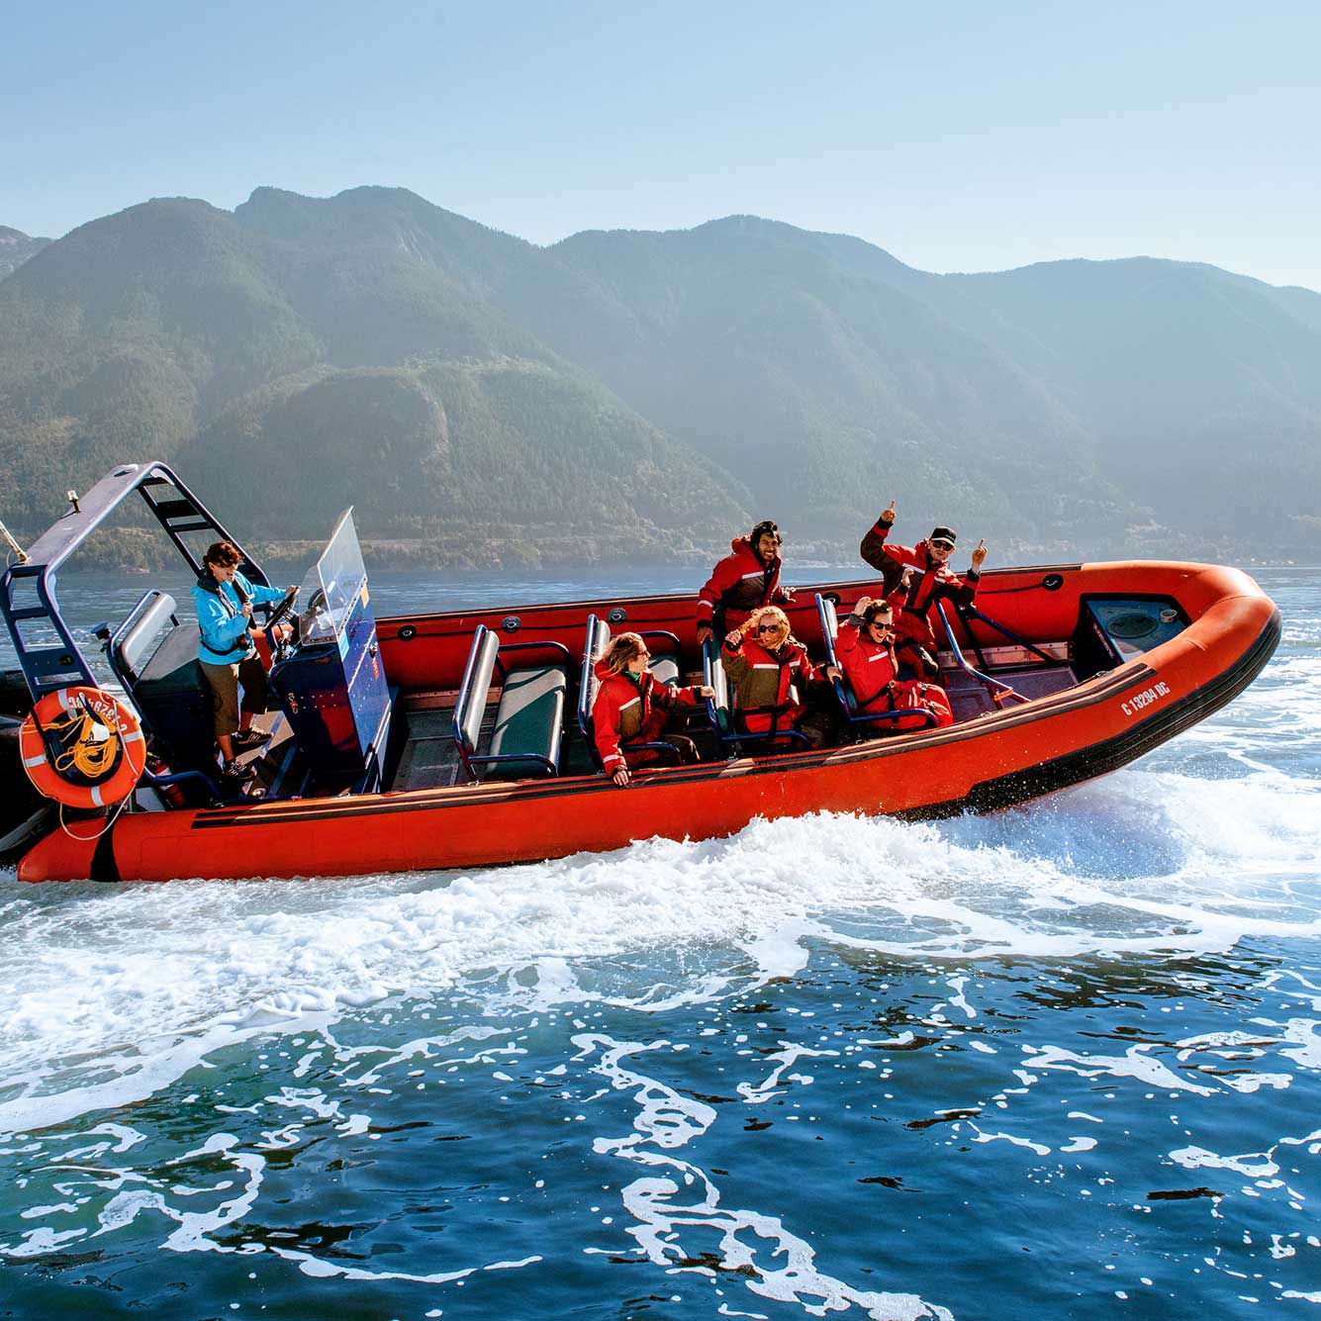

River Rafting

Tourism Distribution by geography

Tourism SMEs operate in every province and territory in Canada and their geographical distribution is roughly proportional to the distribution of other SMEs. As seen in Figure 2, tourism SMEs are predominantly concentrated in Ontario (35.9%) and Quebec (22.4%). In Atlantic Canada, Quebec, British Columbia and Canada's North (as an aggregate of Yukon, Northwest Territories and Nunavut), the concentration of SMEs in tourism industries surpasses the concentration of SMEs in all other industries.[5]

# Bibliography

James, Y. P. (2020). *What If?* Montreal.

Jane, M. (2021). *Spiderverse II.* Montreal.

Rowling, J. K. (2023). *The Art of Sleeping.* California.

Stark, T. (2021). *I Love You 3000.* New York.

1. www.trivanga.com
2. www.hifi.com
3. www.sirius.com
4. www.aboutcanada.com
5. www.loki.com